Biological Science Year 8

Mid Topic Test

Name: _______________________________________ Total: 68 marks

Part A: Multiple-Choice (10 marks)

1. A specimen prepared for a normal classroom light microscope needs to be very thin so;
2. the cover slip sits nicely on top of it.
3. light will pass through it.
4. electrons can pass through it.
5. it fits in the field of view.
6. A micrometre is:
7. one-thousandth of a millimetre.
8. one-thousandth of a centimetre.
9. one-thousandth of a metre.
10. one-hundredth of a millimetre.
11. Which of the following is true:
12. only animal cells contain cytoplasm.
13. only animal cells contain vacuoles.
14. only plant cells have a cell membrane.
15. both plant and animal cells contain a nucleus.
16. Nerve cells:
17. carry information from your brain to other parts of your body.
18. come in three types, voluntary, involuntary and cardiac.
19. carry oxygen and fight infection.
20. produce heat for the body and store energy.
21. The four types of tissue in the human body are:
22. bone, nerve, epithelium and connective.
23. nerve, blood, epithelium and connective.
24. blood, nerve, muscle and skin.
25. connective, epithelium, muscle and nerve.
26. Stem cells are:
27. cells that are found in plant stems.
28. cells that have a special job to do.
29. cells that become different types of cells under specific conditions.
30. cells that work in pairs to open and close the stomata.
31. Which of the following is true about the liver?
32. it is the body’s largest organ.
33. it performs more than 500 different chemical processes.
34. it produces bile.
35. all of the above.
36. Gas exchange in the lungs occurs at the:
37. trachea.
38. alveoli.
39. bronchiole.
40. villi.
41. Food in the stomach undergoes:
42. both chemical and mechanical digestion.
43. mechanical digestion only.
44. chemical digestion only.
45. no form of digestion.
46. In a complex organism the correct order from most to least is:
47. cells, tissue, systems, organs.
48. cells, organs, tissue, systems.
49. cells, tissue, organs, systems.
50. organs, cells, tissue, systems.

END OF PART A

**Part B: Short Answer** (58 marks)

1. **Match** the following terms with their correct meaning. **Note: not all words will be used.**

Magnification, microscopic, micrometre, centimetre, animal cell, plant cell, mitochondria, nucleus, chloroplasts, photosynthesis, Hooke, Leeuwenhoek, unicellular, multicellular, nerve cell, muscle cell, blood cell, guard cell, conducting cells, tissue, organ, system, epithelium, mitosis, digestion, respiration, mechanical digestion, chemical digestion, trachea, oesophagus, breathing.

a) Cell division that produces two new identical cells _______________________________

b) Too small to see with the naked eye __________________________________________

c) A group of cells that perform the same function in the body ________________________

d) The process of getting air into the lungs _______________________________________

e) The first person to observe a cell _____________________________________________

f) Made of many cells ________________________________________________________

g) A cell with no cell wall or chloroplasts ________________________________________

h) The control centre of a cell __________________________________________________

i) Used to measure microscopic objects __________________________________________

j) The tube that carries air from the nose and mouth to the lungs ______________________

(10 marks)

2. **Draw** and **label** an animal cell and a plant cell:

(5 marks)

3. a) **Describe** how mechanical and chemical digestion are different:

___________________________________________________________________________

___________________________________________________________________________

___________________________________________________________________________

___________________________________________________________________________

(2 marks)

b) **Explain** why *not* all cells in a body are the same:

___________________________________________________________________________

___________________________________________________________________________

___________________________________________________________________________

(2 marks)

4. a) **List** three specialised animal cells ____________________________________________

(3 marks)

1. **Name** three types of microscopes _____________________________________________

(3 marks)

1. **List** two organs in the digestive system ________________________________________

(2 marks)

5. **Justify** the following statement: *Respiration and breathing are not the same thing.*

___________________________________________________________________________

___________________________________________________________________________

___________________________________________________________________________

___________________________________________________________________________

(2 marks)

6. **Explain** how villi help with the process of absorption in the intestine: ___________________

___________________________________________________________________________

___________________________________________________________________________

___________________________________________________________________________

(2 marks)

7. **Classify** the following as mechanical or chemical digestion:

1. teeth chewing food _______________________________________________________
2. saliva in the mouth _______________________________________________________
3. stomach wall churning food ________________________________________________
4. pancreatic juice working on carbohydrate _____________________________________

(4 marks)

8. **Identify** the parts of the respiratory system:

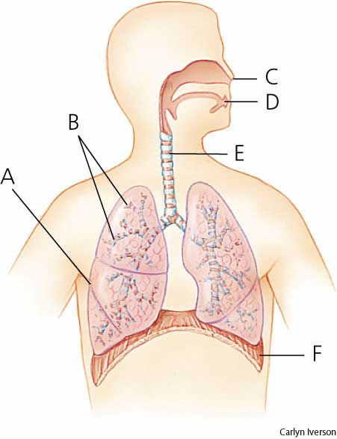

(6 marks)

9. The following table shows the composition of air when it is inhaled and exhaled.

|  |  |  |
| --- | --- | --- |
| **Gas** | **Percentage (%)** | |
| **Inhaled Air** | **Exhaled Air** |
| **Nitrogen** | 78 | 78 |
| **Oxygen** | 21 | 17 |
| **Other gases** | 1 | 1 |
| **Carbon Dioxide** | 0.04 | 4 |

a) Graph the results above as a double column graph. (5 marks)

b) Which gas has the highest percentage when inhaled? _________________________

(1 mark)

c) If you breathed in and out using the same air. **Estimate** how many times you could

breath in before all the oxygen was gone

____________________________________________________________________

(1 mark)

d) **Compare** the percentage of nitrogen inhaled with the percentage of oxygen inhaled.

_____________________________________________________________________

_____________________________________________________________________

(1 mark)

e) **Calculate** how much the percentage of carbon dioxide increases.

_____________________________________________________________________

(1 mark)

f) **Explain** why the percentage of nitrogen does not change.

_____________________________________________________________________

_____________________________________________________________________

_____________________________________________________________________

(2 mark)

10. **Calculate** the following:

|  |  |  |
| --- | --- | --- |
| Ocular lens | Objective lens | Total magnification |
| x4 | x10 |  |
| x10 | x100 |  |
| x4 | x40 |  |
| x10 | x10 |  |

(4 marks)

11. **Define** the following:

i) Nerve cell ____________________________________________________________

___________________________________________________________________________

ii) Specialised cells ______________________________________________________

___________________________________________________________________________

(2 marks)